**Computer Programming 1  
Essential Standard 5.05** Apply Looping Statements

In all programs, put your name, the assignment name and the date in comments at the top.

1. Create a project called Powerof2. Add the controls shown below with appropriate naming.  
   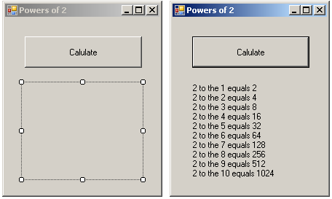
   1. When the button is clicked, you want the output displayed.
   2. In the button click, you want the following to happen.
      1. Since you know how many times you want the code to happen (loop), you will want to use a For loop to show the first 10 powers.
      2. You can use the counter as your exponent variable.
      3. Think about what you want to happen each time the loop iterates:  
         Display “2 to the” exponent “equals ” 2exponent
      4. Create your For loop.  
         For intExpon= 1 To 10  
         Next
      5. Add the code inside the loop  
         lblAnswer.Text &= “2 to the ” & intExpon & “ equals ” & 2 ^ intExpon & vbCrLf
      6. Run your code.
2. Create a project called Factorial. Add the controls shown below with appropriate naming.  
   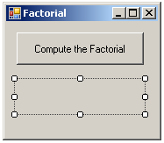
   1. When the button is clicked, the following should happen.
      1. Get the user’s input of a number using an InputBox.
      2. Calculate the Factorial using a For..Next loop
         * Remember the factorial of a number is   
           n * n-1 * n-2 * … * 1  
           Factorial of 3 = 3 * 2 * 1
   2. Display the answer in the label.
3. Create a project called Unlock. Add the controls shown below with appropriate naming.  
   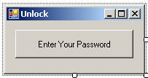
   1. This program should prompt the user to set the passcode, such as “code” or “1234”, using an InputBox. Then the program should prompt the user to enter the code to “unlock”, again using an InputBox.
   2. When the button is clicked, the following should happen.
      1. You will need variables to hold the correct code and the user’s entered code.
      2. Set the correct code using an InputBox.
      3. Get the user’s input of the entered code using an InputBox.
      4. Use a while loop to check if the entered code is the actual code.
         * If it is not, display the message “Code incorrect. Please enter the code to unlock” and prompt for the code again using an InputBox
      5. Add a counter inside your loop to see how many times it took to get the code correct.
      6. Display the following message when the code is correct. “Code entered matches the actual code. It took you # tries.”
4. Create a project called AvgGrade. Add the controls shown below with appropriate naming.  
   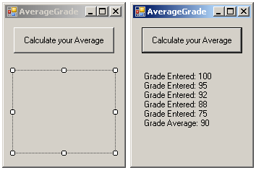
   1. When the button is clicked, the following should happen.
      1. The user should enter 5 numeric test grades using the InputBox to get input.
         * If you know how many times you want the code to happen (5), what kind of loop should you use?
      2. Each grade should be displayed as shown after it is entered.
         * Remember to add to the text in your label.
      3. You will need to keep a “running total” (accumulator) for the grades.
      4. Calculate the average.
      5. Display the average as shown.
5. Create a project called Motivation. Add the controls shown below with appropriate naming.  
   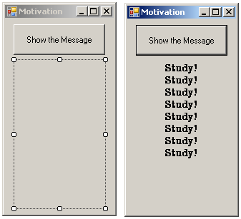
   1. When the button is clicked, the following should happen.
      1. Set the number of times to display the message using an InputBox.
         * The user should enter a number between 1 and 10.
      2. Use a while loop to verify the user entered a number between 1 and 10.
      3. Use a For..Next loop to display the message the entered number of times in the label.
6. Create a project called QuizInput. Add the controls shown below with appropriate naming.  
   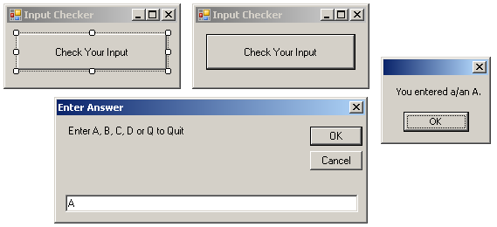
   1. When the button is clicked, the following should happen.
      1. Get the input from the user from an InputBox.
      2. While the input is something other than an A, B, C, D or Q, you should prompt the user again for input.
      3. If the input is an A, B, C, D, you should set the input to a character variable to hold the user’s answer choice and display the choice in a MessageBox, then the program should close.
      4. If the input is a Q, the program should close.

**Challenge Program**

1. Create a project called testScores. Add the controls shown below with appropriate naming. When the button to enter scores is clicked, the user should be able to enter as many test scores as desired using an InputBox. When the show stats button is clicked, the high, low and average score should be displayed. The highest test score that can be earned is 100 and the lowest is 0. You can set a flag to equal -1.  
   